1. INTRODUCTION :

AGRICULTURE IS THE MAIN SOURCE FOR THE PEOPLE TO EARN. MOST OF THE POPULATION IN THE RURAL AREAS IS DEPENDENT ON AGRICULTURE AS THEIR MAIN SOURCE OF INCOME.

* 1. OVER VIEW:

AN EVOLUTIONARY PROCESS THAT CONSISTS OF A SERIES OF ACTIVITIES SUCH AS THE PRODUCTION OF FOOD, FIBERS, FEED, AND RAISISN OF DOMESTICATED ANIMALS TO FULFILL THE DEMAND OF THE POPULATION.

1.2.PURPOSES:

AGRICULTURE PROVIDES MOST OF THE WORLD’S FOOD AND FABRICS. COTTON, WOOL, AND LEATHER ARE ALL AGRICULTURAL PRODUCTS.

1. PROBLEM STATEMENT AND DESIGN THINKING:

A COMPANY COULD USE DESIGN THINKING TO CREATE A NEW HARVESTER THAT IS MORE VERSATILE AND ADAPTABLE TO DIFFERENT CROPS.

2.1.EMPATHY MAP: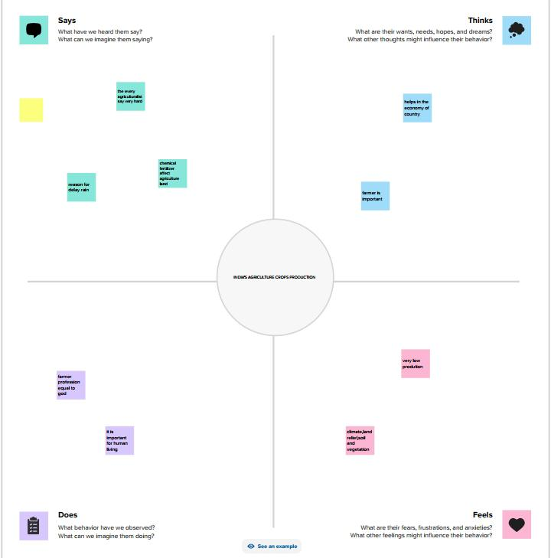

2.2.IDEATION AND BRAINSTORMING MAP:

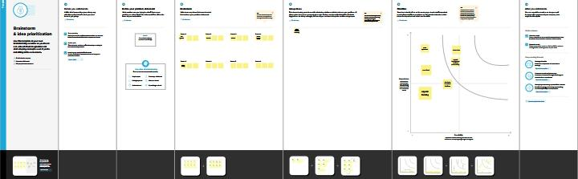

1. RESULT:

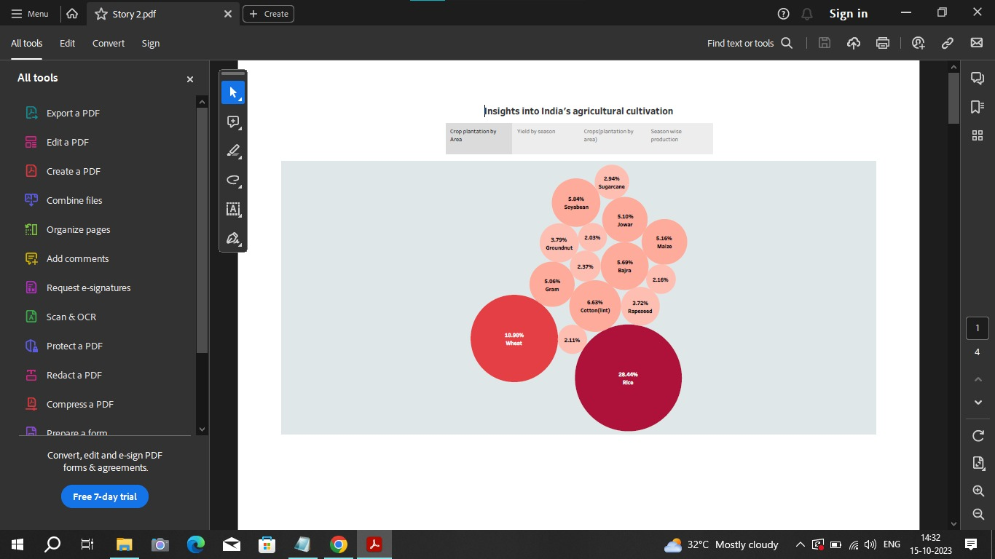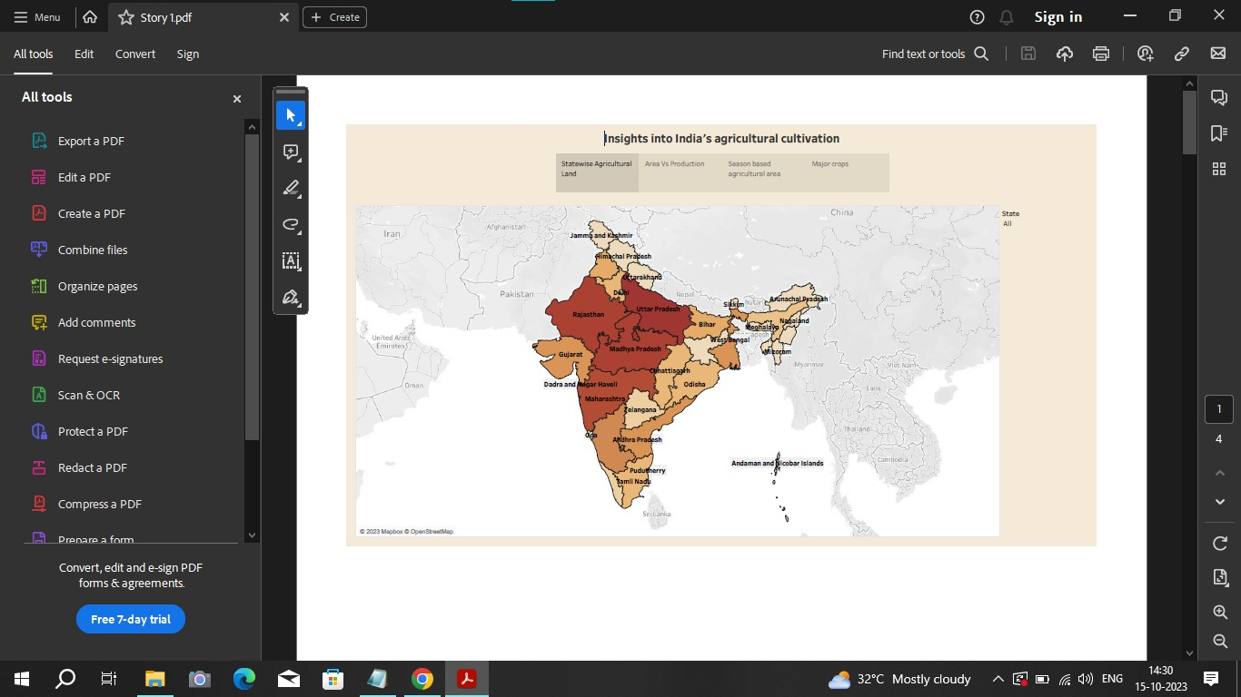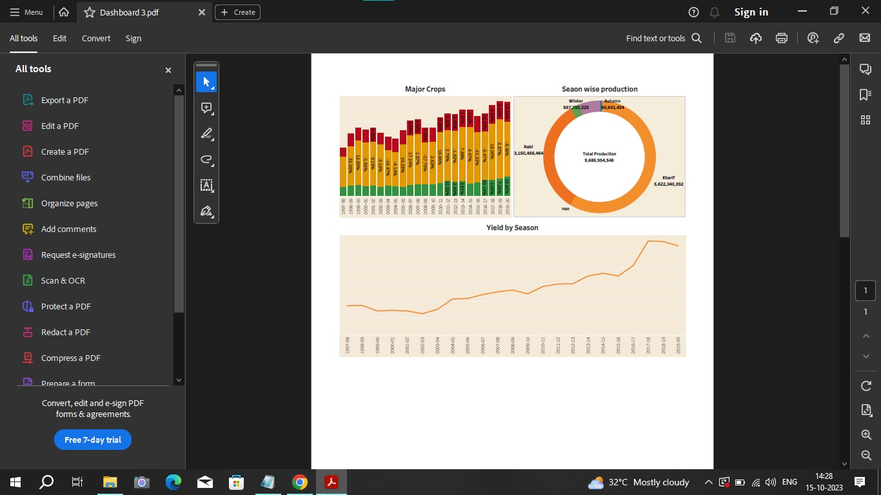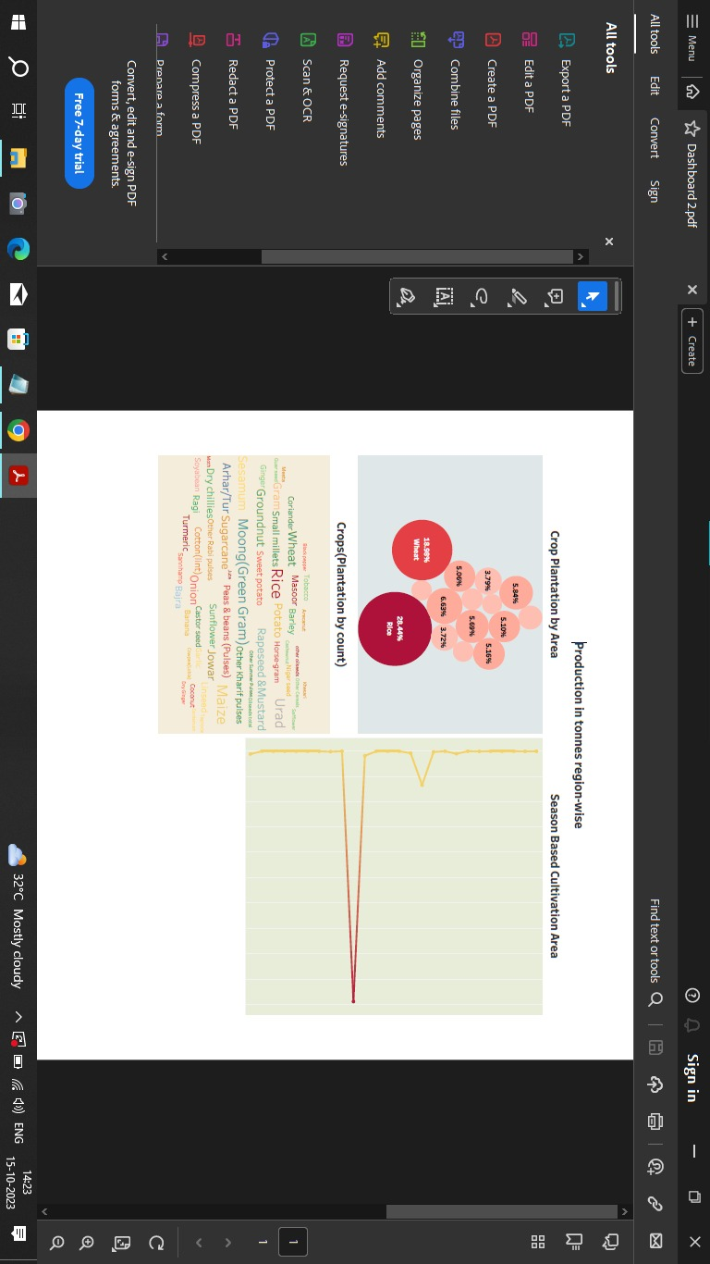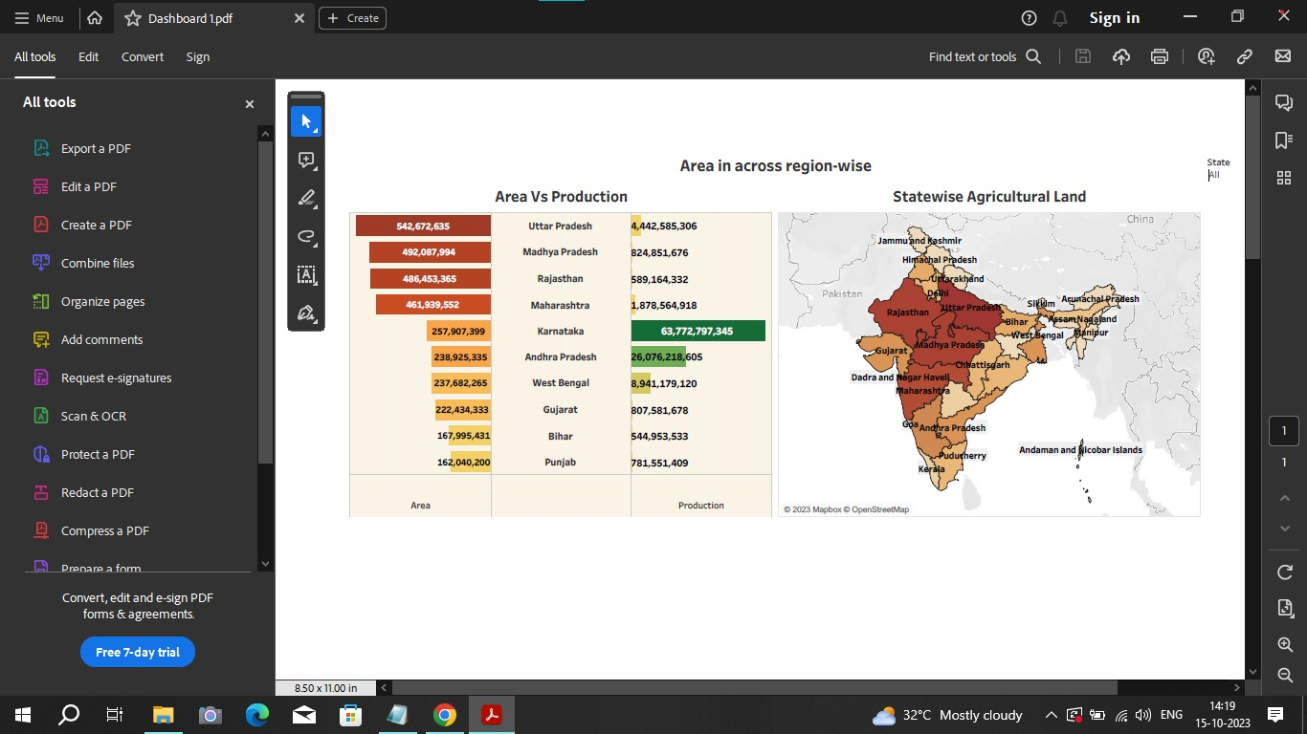

1. ADVANTAGES AND DISADVANTAGES:

SUPPORTING LIVELIHOODS THROUGH FOOD, HABITAT, AND JOBS; PROVIDING RAW MATERIALS FOR FOOD AND OTHER PRODUCTS; AND BUILDING STRONG ECONOMIES THROUGH TRADE.

EROSION OF SOIL BY HEAVY RAIN, FLOODS, INSUFFICIENT VEGETATION COVER ETC., REDUCES FARM PRODUCTIVITY.

1. APPLICATION:

AL HELPS FARMERS BY SUGGESTING THE NUTRIENTS THEY SHOULD APPLY TO INCREASE THE QUALITY OF THE SOIL. AL CAN HELP FARMERS CHOOSE THE OPTIMAL TIME TO PLANT THEIR SEEDS. INTELLIGENT EQUIPMENT CAN CALCULATE THE SPACING BETWEEN SEEDS AND THE MAXIMUM PLANTING DEPTH.

1. CONCLUSION:

INDIAN’S AGRICULTURE SECTOR IS STILL VERY IMPORTANT TO THE INDIAN ECONOMY, ALTHOUGH ITS SHARE OF THE ECONOMY HAS DECREASED OVER THE PAST 50 YEARS.

1. FUTURE SCOPE:

AL CAN ANALYZE MARKET DEMAND, FORECAST PROCES AS WELL AS DETERMINE OPTIMAL TIMES FOR SOWING AND HARVESTING.